Design and Implementation of a Multilingual Speech to Text and Translation System for Hausa and English Languages
ABSTRACT
Language differences can restrict the exchange of information between people who communicate more comfortably in Hausa and those who rely on English. Although digital translation services are increasingly available, many require typed input or separate tools for recording, transcription, translation and speech synthesis. This project presents the design and implementation of a web-based multilingual speech-to-text and translation system for Hausa and English. The system allows a user to record speech through a browser microphone or upload an audio file, select a translation direction, obtain the original transcript, translate the transcript into the target language, and listen to the translated text as generated speech. Users can also copy results and save or delete transcription and translation history. The application was developed with React and Vite for the user interface, Node.js and Express for the server-side application programming interface, and MongoDB for persistent storage. Google Gemini models were integrated through the backend to provide audio understanding, translation and text-to-speech generation, while browser media capabilities support voice recording and playback. The development follows a modular client-server approach in which credentials and AI processing remain on the server. The system is intended for general Hausa and English speakers and demonstrates how automatic speech recognition, machine translation and speech synthesis can be combined in one accessible workflow. Its performance can be assessed through functional testing, Word Error Rate for transcription, human assessment of meaning preservation and fluency for translation, and usability feedback. The study contributes a practical software implementation for Hausa-English communication while recognising limitations associated with internet dependency, model availability, accent, dialect and background noise.
Keywords: speech-to-text, automatic speech recognition, machine translation, Hausa, English, text-to-speech, multilingual system

CHAPTER ONE
INTRODUCTION

1.1 Background of the Study
Language is the principal means through which people exchange ideas, knowledge and experiences. Communication becomes difficult when participants do not share the same language or when one person cannot conveniently read or write the language used by another. This challenge is common in multilingual societies such as Nigeria, where English is widely used in education, government and formal communication, while Hausa is a major language of everyday interaction across northern Nigeria and other parts of West Africa. A practical connection between both languages can therefore improve access to information and support communication among their speakers.
Developments in artificial intelligence have changed the way people interact with computers. Natural Language Processing enables computers to work with human language, while speech technologies allow spoken information to be converted into text and generated from text. Automatic Speech Recognition converts speech into a written transcript, Machine Translation expresses the transcript in another language, and Text-to-Speech converts the translated text into audible output. Combining these functions allows a user to speak in one language and receive both written and spoken output in another language.
Speech input can be more convenient than typing, particularly when a user already has an audio recording, uses a mobile device or is uncertain about spelling. However, speech recognition can be affected by background noise, microphone quality, accent, pronunciation, speaking speed and dialect. Translation may also be difficult when a word has several meanings or when an expression is culturally specific. Displaying both the recognised transcript and the translation helps the user identify whether an error occurred during recognition or translation.
Although digital language technologies have improved, Hausa remains less represented than English in many datasets, tools and evaluation resources. Muhammad et al. (2025) identify limited open datasets, dialectal variation and inadequate model representation as continuing challenges for Hausa Natural Language Processing. Progress is nevertheless being made. Ibrahim et al. (2022) developed a Hausa speech dataset containing approximately 47 hours of recorded speech, demonstrating the growing potential for Hausa speech recognition and synthesis.
A person who wants to translate spoken Hausa or English may have to use separate applications for recording, transcription, translation and speech generation. Moving between different tools increases the number of steps and makes it difficult to preserve the original transcript and corresponding translation as one record. An integrated web application can simplify this process by providing language selection, recording, audio upload, transcription, translation, playback and saved history within one interface.
This study therefore presents the design and implementation of a web-based multilingual speech-to-text and translation system for Hausa and English. The system allows users to record speech through a browser or upload an audio file, obtain the original transcript, translate it into the other supported language, listen to the translated result and save useful outputs. It was implemented with React and Vite on the frontend, Node.js and Express on the backend, MongoDB for persistent history and Google Gemini services for audio processing, translation and voice generation. The study focuses on integrating these technologies into an accessible and testable application rather than training a new language model.

1.2 Statement of the Problem
Communication between Hausa and English speakers may be restricted when one party does not understand the language used by the other. Many translation tools depend mainly on typed input, even though a user may possess an audio recording, prefer to speak or find it difficult to type the source language correctly. Depending only on text input therefore does not address every practical communication situation.
The required process is also commonly divided among different applications. A user may record speech with one tool, transcribe it with another, paste the text into a translator and use a separate service to hear the translated output. This fragmented process is inconvenient, creates more opportunities for error and does not preserve the transcript and translation together for later use. The challenge is greater for Hausa because recognition and translation may be affected by limited language resources, regional pronunciation, code-switching and background noise.
There is consequently a need for a focused system that accepts Hausa or English speech, displays the recognised transcript, translates it into the other language, generates playable voice output and stores selected results in one application. The output should remain visible so that users can inspect possible errors, while the implementation should protect API credentials and handle audio securely. This study addresses that need through the development of the Hausa-English multilingual speech-to-text and translation system.

1.3 Aim of the Study
The aim of this study is to design and implement a web-based multilingual speech-to-text and translation system capable of processing Hausa and English speech, translating the recognised text into the corresponding target language and generating spoken output from the translation.

1.4 Objectives of the Study
1. To design a responsive web interface through which users can select Hausa or English, record speech or upload an audio file.
2. To implement speech-to-text conversion for Hausa and English audio.
3. To implement bidirectional translation from Hausa to English and from English to Hausa.
4. To integrate text-to-speech generation for playing translated Hausa and English output.
5. To develop a history function for saving, retrieving and deleting transcription and translation results.
6. To evaluate the system in terms of functional correctness, transcription accuracy, translation quality and usability.

1.5 Significance of the Study
The study is significant to general Hausa and English speakers because it provides one interface for speaking, reading and listening across both languages. Users can record speech instead of typing, inspect the transcript and translation, and play the translated output. This makes short multilingual exchanges more convenient while allowing the result to be checked before use.
Students and educators may use the system for bilingual learning exercises, short recorded explanations and comparison of spoken and written language. The application is not a replacement for a teacher or professional interpreter, but it can serve as a supporting language and educational tool.
The study is also useful to researchers and developers interested in African-language technology. It provides a practical example of integrating browser recording, a React frontend, an Express API, Gemini language services and MongoDB storage. Its visible transcript and proposed evaluation approach may support investigation of Hausa recognition, translation and pronunciation errors.
Organisations that communicate with Hausa and English speakers may use the design as a foundation for future public-information, customer-support or community-service applications. More extensive accuracy, privacy and security testing would be required before use in high-stakes environments.

1.6 Scope of the Study
The study is limited to Hausa and English and supports two translation directions: Hausa speech to English and English speech to Hausa. Users can record speech through the browser microphone or upload an existing audio file. The system displays the original transcript and translation, provides copying and translated voice playback, and allows selected results to be saved or deleted from history.
The technical scope covers a responsive React and Vite frontend, a Node.js and Express backend, MongoDB storage and Gemini services for transcription, translation and text-to-speech generation. Audio is processed for the active request and is not intentionally stored as a permanent database record. The saved history contains text, language direction and basic audio metadata.
The evaluation scope covers the correctness of recording, uploading, processing, copying, playback and history functions. Speech and translation quality may be assessed with selected Hausa and English recordings, verified transcripts and bilingual judgement. The study does not represent every Hausa dialect, English accent, speaker or recording environment.

1.7 Definition of Terms
Automatic Speech Recognition: The process of converting spoken Hausa or English audio into written text.
Machine Translation: The automatic conversion of recognised text from Hausa to English or from English to Hausa while attempting to preserve meaning.
Text to Speech: The generation of playable audio from the translated text.
Multilingual System: An application that processes more than one language; Hausa and English in this study.
Transcript: The written representation produced from the words recognised in an audio recording.
Translation History: Saved records containing the language direction, transcript, translation and related metadata.
Application Programming Interface: The connection through which the frontend communicates with the backend and its services.
Word Error Rate: A speech-recognition measure based on substitutions, deletions and insertions relative to a verified transcript.
Usability: The degree to which intended users can understand and operate the system effectively and with reasonable ease.

CHAPTER TWO
LITERATURE REVIEW

2.1 Introduction
This chapter reviews the concepts, theories, technologies and earlier studies that provide the foundation for the design of a Hausa-English speech-to-text and translation system. The review begins with human language technology and then examines automatic speech recognition, machine translation, text-to-speech synthesis, multilingual and low-resource language processing, web-based system integration and evaluation. It also considers related systems and empirical studies in order to identify the gap addressed by the present work. The central argument of the chapter is that recent multilingual models make an integrated Hausa-English speech workflow feasible, but accuracy, transparency, accessibility and language-specific evaluation remain important concerns.

2.2 Review of Existing Systems or Technologies

2.2.1 Natural Language Processing
Natural Language Processing (NLP) is the area of artificial intelligence concerned with enabling computers to analyse, interpret and generate human language. It connects computer science, linguistics and machine learning. NLP systems handle text tasks such as classification, translation, information extraction and question answering, while speech-language systems extend the same principles to acoustic input and spoken output. Human language is difficult for computers because meaning depends on vocabulary, grammar, discourse, social context and shared cultural knowledge. A word may have several meanings, an expression may be idiomatic, and the intended interpretation may depend on words that appeared much earlier in a sentence.
Earlier language-processing systems relied heavily on hand-written rules and statistical models. Rule-based systems offered clear linguistic control but were costly to extend because specialists had to anticipate many grammatical and lexical cases. Statistical systems learned probabilities from corpora, but their performance depended strongly on engineered features and aligned training data. Neural networks shifted the emphasis toward learning representations directly from examples. The Transformer architecture introduced by Vaswani et al. (2017) uses attention mechanisms to relate different parts of a sequence and supports parallel computation. It became central to modern translation and large language models.
For this study, NLP provides the bridge between speech recognition and translation. The spoken signal is first represented as text; the text is then interpreted in the source language and expressed in the target language. Because Hausa and English differ in vocabulary, syntax and cultural expression, the system must preserve meaning rather than substitute isolated words. The use of a generative multilingual model allows one backend request to perform transcription and translation while a structured JSON response keeps the application output predictable.

2.2.2 Automatic Speech Recognition
Automatic Speech Recognition (ASR) converts an acoustic speech signal into a sequence of written words. A speech waveform contains variations caused by phonemes, speaker characteristics, rate, emotion, microphone quality and the environment. A conventional ASR pipeline includes signal acquisition, feature extraction, acoustic modelling, language modelling and decoding. End-to-end neural approaches combine several of these stages and learn a direct relationship between audio and text.
Self-supervised learning has improved ASR by allowing models to learn general speech representations from large quantities of unlabelled audio. Wav2vec 2.0 learns representations from raw waveform data and can be fine-tuned with a smaller labelled set, demonstrating that good recognition can be obtained with less transcription than fully supervised approaches require (Baevski et al., 2020). Whisper used large-scale weak supervision from diverse multilingual audio and showed strong transfer across recognition and translation tasks, although accuracy still differs by language and condition (Radford et al., 2023).
In the developed system, audio enters through the browser microphone or file upload. The browser MediaRecorder interface captures speech as a media blob, which is submitted as multipart form data. The backend checks that the content is an audio type and restricts the upload to 15 MB. It then supplies the audio bytes and a language-specific instruction to Gemini. The model returns a source transcript and target translation. Showing the transcript is important because it enables the user to determine whether a translation problem began at recognition or at the translation stage.
ASR errors are commonly classified as substitutions, deletions and insertions. Word Error Rate is expressed as WER = (S + D + I) / N, where S is the number of substituted words, D is the number of deleted words, I is the number of inserted words and N is the number of words in the verified reference transcript. A value of zero means an exact word match; higher values indicate more recognition errors. WER is useful but does not capture every aspect of meaning, punctuation or acceptable spelling variation.

2.2.3 Machine Translation
Machine Translation (MT) automatically produces a target-language text from a source-language text. Its quality depends on adequacy and fluency. Adequacy concerns whether the meaning and information in the source are preserved, while fluency concerns whether the target sentence is natural and grammatically acceptable. Translation is not a word-for-word mapping because languages organise meaning differently. Named entities, idioms, tense, gender, politeness and implied context can all affect the correct output.
Neural machine translation represents words or subword units as vectors and learns to predict a target sequence from a source sequence. Attention helps the model assign importance to relevant source elements while generating each target element (Vaswani et al., 2017). Multilingual models share parameters across many languages, which may transfer useful patterns from languages with more data to languages with fewer resources. The No Language Left Behind project demonstrated large-scale multilingual translation across 200 languages and placed particular emphasis on low-resource coverage (Costa-jussà et al., 2022).
A cascaded speech translation system separates recognition and translation conceptually, even when both tasks are requested from the same cloud model. This separation supports inspection: the user sees what the system understood before seeing how it translated that content. Direct speech-to-speech systems can reduce visible intermediate steps, but the hidden transcript makes diagnosis more difficult. SeamlessM4T shows that ASR, speech-to-text translation, text translation and speech generation can be supported within a massively multilingual model (Barrault et al., 2023). The present application retains visible textual stages because they are useful to users and evaluators.
Automatic translation measures such as BLEU compare machine output with one or more reference translations using overlapping word sequences (Papineni et al., 2002). Such metrics are repeatable but may penalise valid alternative translations. Human assessment is particularly valuable for Hausa because several natural renderings may express the same idea. A practical evaluation should therefore consider meaning preservation, grammatical correctness, naturalness and culturally appropriate word choice.

2.2.4 Text to Speech Synthesis
Text-to-Speech (TTS) converts written language into audible speech. A TTS system analyses text, determines pronunciation and prosody, and synthesises an acoustic waveform. Older systems joined recorded speech segments or generated speech using parametric models. Neural synthesis systems learn mappings from text and speaker or style representations to acoustic output, producing more natural rhythm and intonation.
Voice output expands the value of a translation application. It assists users who prefer listening, supports pronunciation practice, and creates a closer approximation to spoken communication. In this project, the translated result contains a Play control. The frontend sends the translated text and target-language code to the backend. Gemini 3.1 Flash TTS Preview generates audio using the configured voice, and the backend wraps returned pulse-code modulation data in a WAV header before returning it to the browser. Google’s documentation describes Gemini TTS as controllable speech generation that accepts natural-language direction for style and delivery (Google, 2026b).
TTS quality can be judged by intelligibility, naturalness, pronunciation and appropriateness of pacing. Hausa evaluation should include common words, borrowed terms, proper names and regional expressions. A pleasant voice is not sufficient if words are pronounced in a way that changes meaning. Voice generation is therefore presented as a convenience feature, while displayed text remains available for verification.

2.2.5 Hausa as a Low Resource Language
Hausa is widely used in northern Nigeria and across parts of West and Central Africa, but widespread use does not automatically produce sufficient digital resources. A high-resource language has large, diverse and carefully annotated corpora, tools and benchmarks. A low-resource language may lack balanced text, transcribed speech, pronunciation data and standard evaluation sets. Muhammad et al. (2025) describe Hausa NLP as growing but still affected by limited open datasets, dialectal variation, suboptimal tokenisation and inadequate representation in large language models.
Dialect and pronunciation differences are important for Hausa speech processing. A model trained predominantly on one speech variety may perform less accurately for another. Code-switching is also common in multilingual communities: a speaker may insert English names, technical terms or phrases into Hausa speech and vice versa. Background noise and lower-quality mobile microphones introduce further variation. These factors justify testing with more than one speaker and recording environment.
Language-resource development has nevertheless improved. Ibrahim et al. (2022) reported a Hausa read-speech dataset of approximately 47 hours recorded by native speakers for research in recognition and synthesis. BibleTTS includes Hausa within a multilingual African corpus designed for high-quality speech synthesis research (Meyer et al., 2022). These resources show meaningful progress, while their domains and speaker coverage also illustrate why broad real-world performance cannot be assumed from a single dataset.
The present system does not train a Hausa model. It uses a hosted multilingual model and contributes at the application-integration level. This is appropriate for a final-year implementation because model training would demand substantial data, specialised hardware and lengthy experimentation. The design still recognises low-resource concerns by specifying the language explicitly, retaining the original transcript, supporting both translation directions and recommending Hausa-speaker evaluation.

2.2.6 Web Based Multilingual Systems
A web-based system runs through a browser and can be accessed across desktops and mobile devices without a platform-specific installation. The browser provides interface rendering, microphone permission, audio capture, file selection and playback. A backend server provides validation, external-service access and persistent storage. This division is especially important when secret API keys are involved because credentials embedded in frontend JavaScript can be discovered by users.
The developed application follows a client-server architecture. React manages the interface and state; Vite provides the development and production build process; Node.js runs server-side JavaScript; Express defines the HTTP endpoints; Multer validates and receives audio files; and Mongoose maps translation records to MongoDB documents. Cross-Origin Resource Sharing is restricted through the configured client URL during separate frontend and backend development.
Responsive design allows the translation workspace to adapt to smaller screens. The interface provides visible process stages, loading states, error messages and disabled controls where an action is unavailable. These features reduce ambiguity. Nielsen (1994) argues that usable interfaces should make system status visible, match users’ expectations, prevent errors and support recovery. The application reflects these principles by displaying processing states, requiring audio before submission, confirming destructive history clearing and allowing the current workspace to be reset.

2.2.7 Speech and Language Evaluation
Evaluation must address both technical correctness and language quality. Functional testing asks whether each component behaves according to its requirement. ASR evaluation compares transcripts with reference text. Translation evaluation considers semantic accuracy and fluency. TTS evaluation considers intelligibility and naturalness. Usability evaluation asks whether intended users can complete tasks efficiently and understand system feedback. ISO/IEC 25010:2023 groups software quality around characteristics that include functional suitability, performance efficiency, compatibility, interaction capability, reliability, security, maintainability, flexibility and safety. A student project can use a selected subset of these characteristics without claiming full certification.
Table 2.1 Suggested evaluation dimensions
Component | Measure | Interpretation
Speech to text | Word Error Rate | Lower values indicate fewer word-level errors.
Translation | Meaning, grammar and fluency ratings | Higher human ratings indicate a more acceptable translation.
Voice output | Intelligibility and naturalness | Listeners assess whether the output is understandable and sounds natural.
Interface | Task completion and user feedback | Shows whether users can operate the workflow successfully.
Software functions | Pass or fail test cases | Confirms that requirements and error controls behave as designed.

2.3 Related Work and Research
Table 2.3 Summary of empirical studies
Study | Focus | Main contribution | Relevance
Vaswani et al. (2017) | Machine translation | Introduced the Transformer and demonstrated attention-based sequence modelling. | Provides the architectural foundation for modern multilingual models.
Baevski et al. (2020) | Speech representation | Used self-supervised learning on raw audio and reduced dependence on labelled speech. | Explains current progress in adapting speech models with limited labelled data.
Radford et al. (2023) | Multilingual ASR | Trained Whisper with large-scale weak supervision for robust recognition and translation. | Shows the value and limitations of broad multilingual speech training.
Ibrahim et al. (2022) | Hausa speech data | Developed about 47 hours of native Hausa read speech. | Confirms Hausa resource growth and the importance of language-specific data.
Meyer et al. (2022) | African TTS corpus | Released BibleTTS covering Hausa and other African languages. | Supports research on more natural African-language speech synthesis.
Costa-jussà et al. (2022) | Low-resource MT | Developed NLLB translation models covering 200 languages. | Shows multilingual transfer at scale and attention to underserved languages.
Barrault et al. (2023) | Multimodal translation | Unified ASR, speech translation, text translation and speech generation. | Demonstrates an integrated direction similar to this application workflow.
Muhammad et al. (2025) | Hausa NLP review | Identified datasets, tools and persistent gaps including dialect and tokenisation. | Directly motivates careful Hausa evaluation and transparent limitations.

The empirical literature indicates steady improvement in multilingual modelling and growing Hausa resources. However, research benchmarks do not automatically become usable applications. A model must be integrated with input validation, user controls, secure credentials, data persistence and error handling. Moreover, reported average performance may hide errors affecting particular dialects, speakers and acoustic conditions. The present work therefore treats application engineering and user-visible verification as part of the research problem.

2.4 Theoretical Framework

2.4.1 The Transformer Model
The Transformer is adopted as the principal computational framework for understanding the language-processing component of this study. Vaswani et al. (2017) replaced recurrence with self-attention, enabling a model to relate every element in a sequence to other relevant elements. Queries, keys and values are projected from input representations; attention weights indicate the relevance of one position to another. Multi-head attention learns different relationships in parallel, while feed-forward layers transform the resulting representations.
For translation, an encoder represents the source sequence and a decoder produces the target sequence. Modern generative models may use related decoder-only or multimodal architectures, but attention remains fundamental. When audio is also accepted, the system must form representations of acoustic information and relate them to language tokens. This explains how one service can receive audio and return both a transcript and a translation.
The framework is relevant because Hausa-English conversion requires long-range context rather than isolated dictionary replacement. The meaning of a word can depend on surrounding words, and translation may require changing word order. Attention-based multilingual learning also permits knowledge sharing across languages. However, a model’s architecture does not eliminate data imbalance. If Hausa has less representative data, the model may still have weaker vocabulary coverage or dialect sensitivity than it has for English.

2.4.2 Human Information Processing and Usability
The interface aspect of the project is also explained through human information-processing principles. A user must perceive available controls, understand the language direction, provide audio, interpret feedback and decide what to do with the result. Working-memory demand increases when these actions are scattered across separate applications. Integrating them in one page reduces context switching and keeps the transcript beside its translation.
The system uses recognition rather than recall by displaying Hausa and English names, visible process stages and familiar icons. Immediate loading and error feedback reduces uncertainty. The original transcript and translated result are separated visually to prevent confusion. The Play button is placed within the translated output because the generated speech belongs to that result. These choices correspond with established usability principles of visibility, consistency, error prevention and user control (Nielsen, 1994).

2.4.3 Application of the Framework to the Study
Together, the Transformer framework and usability principles explain both major sides of the project. Attention-based multimodal language processing explains the conversion of audio into source and target text and the generation of speech. Human-centred interface principles explain how those capabilities are exposed as a comprehensible workflow. The study therefore evaluates not merely whether an AI model responds, but whether the complete application securely accepts input, presents inspectable output, handles errors, stores selected results and supports general Hausa and English speakers.

2.5 Comparison of Existing Solutions
Table 2.2 Comparison of related systems
System | Relevant strength | Difference or limitation
Google Translate | Provides text, speech and camera translation across many languages and offers a mature consumer interface. | It is a general platform rather than a transparent academic implementation whose backend, data model and API flow can be examined.
Google Cloud Speech to Text | Provides specialised cloud ASR with language configuration and production tooling. | Recognition and translation are separate services, increasing integration requirements for a small project.
Whisper | A multilingual model for transcription and speech translation trained with large-scale weak supervision. | Local operation can require significant computation, and language performance differs across evaluation sets.
SeamlessM4T | Supports ASR, text translation, speech translation and speech generation in a unified multilingual research model. | Deployment is technically heavier than a hosted API integration for a straightforward student web application.
NLLB | Targets text translation across 200 languages with attention to low-resource languages. | It does not by itself provide browser recording, speech recognition, voice playback and history management.
Fassara system | Combines recording or upload, visible transcript, Hausa-English translation, voice output and saved history. | Depends on internet access and an external model; broad language accuracy requires continued evaluation.

The comparison shows that existing platforms demonstrate the technical feasibility of multilingual speech and translation. The distinctive value of the present study is not a claim that its model surpasses large commercial services. Its contribution is a focused, understandable and testable Hausa-English application that exposes the complete interaction flow, maintains a local project database, keeps credentials on the server and can be explained at source-code level.

2.6 Research Gap and Justification for the Approach
Many reviewed studies concentrate on model architecture, corpus development or benchmark performance. Consumer translators provide broad capabilities, but their internal implementation and data flow are not available for academic inspection. Other tools focus on one stage, such as recognition or text translation, and require users or developers to connect multiple services.
There remains a practical gap for a focused Hausa-English web implementation that combines microphone recording, audio upload, visible transcription, bidirectional translation, natural voice output and manageable result history. There is also a need to document the ordinary software-engineering decisions surrounding such a system: server-side credential protection, file validation, structured model output, WAV construction, database fallback, responsive interaction and meaningful error messages.
This study addresses that gap through the design and implementation of Fassara. It does not attempt to train a new foundation model or claim universal translation accuracy. Instead, it demonstrates how available multilingual AI can be integrated into a coherent system for general Hausa and English speakers and evaluated honestly through functional, language-quality and usability criteria.

CHAPTER THREE
RESEARCH METHODOLOGY AND SYSTEM DESIGN

3.1 Introduction
This chapter explains how the problem was analysed and how the system was designed before and during implementation. It describes the development method, the existing and proposed workflows, feasibility, requirements, architecture, input and output design, database structure, API design, security controls and evaluation plan. The design emphasises a small number of understandable modules so that the implementation remains maintainable and easy to demonstrate.

3.2 Development Methodology

3.2.1 Iterative Prototyping Approach
An iterative prototyping method was adopted. The project began with the core user journey: select a language direction, provide audio, receive a transcript and obtain a translation. A working interface was then connected to the backend, followed by persistent history and translated voice output. Each increment was tested before the next capability was added. This method was suitable because external AI behaviour and browser audio handling needed practical experimentation rather than complete prediction at the planning stage.
The main iterations were requirement definition, interface prototype, audio capture and upload, backend endpoint development, Gemini transcription and translation integration, MongoDB history integration, text-to-speech integration, error correction, responsive refinement and verification. During speech integration, model availability was handled through environment configuration rather than hard-coding one model throughout the source. The TTS response parser was also aligned with the interactions response structure and returned PCM audio was converted to WAV for reliable browser playback.
Iterative development supports early discovery of integration problems but can produce uncontrolled changes if requirements are not documented. The project therefore maintained a defined MVP scope: Hausa and English only, no authentication, no payment, no custom model training and no permanent audio storage. The requirements and final modules presented in this chapter provide the baseline against which the implementation was tested.

3.2.2 Analysis of the Existing Process
Without an integrated system, a user may record speech in one application, upload it to a transcription service, copy the transcript into a translator and move the translation into a speech generator. The user must maintain the relationship between these outputs manually. The process requires repeated copying, exposes content to several interfaces and provides no project-specific history. Typed translators also exclude speech-first use when the user cannot conveniently type the source message.
Table 3.1 Problems in the existing process
Observed problem | Effect on the user | Required response
Separate applications for each stage | More steps and repeated transfer of content | Combine recording, transcription, translation and playback.
Typed input is often assumed | Users with audio or limited typing convenience face difficulty | Support microphone recording and file upload.
No visible relationship among outputs | The source transcript and target translation may be confused | Display both outputs with clear language labels.
No project-specific storage | Useful translations are easily lost | Provide saved history with deletion controls.
Credentials may be exposed in a frontend-only design | Private API keys can be discovered | Route AI requests through the backend.
Errors may be difficult to interpret | Users do not know how to recover | Validate input and return actionable messages.

3.2.3 Description of the Proposed System
The proposed system is a responsive web application named Fassara. A user selects Hausa-to-English or English-to-Hausa, records speech or uploads an audio file, and submits it for processing. The backend validates the request and sends the audio to Gemini with an instruction requiring a structured transcript and translation. The frontend displays the two results. The user may copy either text, play the translated voice, save the result or clear the workspace. Saved items are available on a history page and can be deleted individually or collectively.
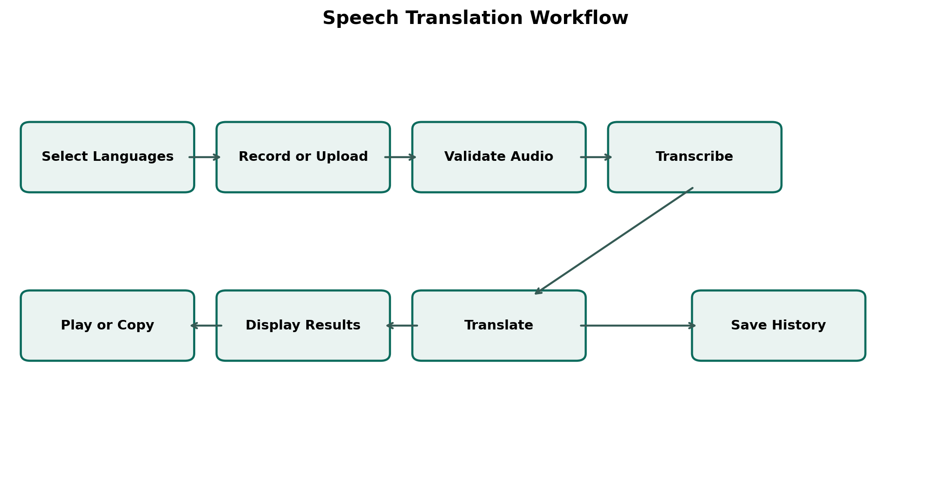
Figure 3.1 Operational workflow of the proposed system

3.2.4 Feasibility Study

3.2.4.1 Technical Feasibility
The application uses widely available web technologies and a hosted multilingual AI service. Modern browsers provide microphone recording through MediaDevices and MediaRecorder. Node.js can process multipart requests and call web APIs without a separate language runtime. MongoDB supports the flexible translation record. Development therefore does not require specialised local GPU hardware. The main technical dependencies are a supported browser, internet connection, Gemini access and a MongoDB connection for permanent history.

3.2.4.2 Operational Feasibility
The workflow is based on familiar actions: select, record, upload, play, copy and save. General Hausa and English speakers do not need to understand machine learning. Visible source and target labels reduce language-direction errors, while the original transcript allows the user to inspect what the model recognised.

3.2.4.3 Economic Feasibility
The software stack is open source. Local development can use MongoDB locally or a free hosted tier, while Gemini usage is controlled through API access and provider quotas. No dedicated model-training infrastructure is required. Operational cost may increase with frequent use because audio and TTS requests consume external service resources.

3.2.4.4 Schedule Feasibility
The limited language scope and reuse of hosted models made the implementation achievable within a final-year project period. Incremental development allowed the core workflow to operate before secondary features such as history and voice output were completed.

3.3 Requirements Analysis

3.3.1 Functional Requirements
Table 3.2 Functional requirements
Code | Requirement
FR01 | The system shall allow Hausa-to-English and English-to-Hausa selection.
FR02 | The system shall record microphone audio through a supported browser.
FR03 | The system shall accept an existing audio file.
FR04 | The backend shall reject missing, non-audio or oversized uploads.
FR05 | The system shall return an original-language transcript.
FR06 | The system shall return a target-language translation.
FR07 | The user shall be able to copy displayed text.
FR08 | The system shall generate and play speech for the translated text.
FR09 | The user shall be able to save a completed result.
FR10 | The history page shall retrieve saved results in recent-first order.
FR11 | The user shall be able to delete one saved result or clear all results.
FR12 | The system shall show loading, success and error feedback.

3.3.2 Non Functional Requirements
Table 3.3 Non functional requirements
Area | Requirement
Usability | The interface should use clear labels, visible status and a small number of steps.
Performance | Ordinary navigation should respond immediately; AI processing time should be represented with a loading state.
Security | API keys shall remain in backend environment variables and uploads shall be validated.
Privacy | Audio shall be held in memory only for the active processing request and shall not be stored in translation history.
Reliability | Errors from recording, the database and external AI shall be caught and communicated.
Compatibility | The interface shall adapt to desktop and mobile widths and use browser-standard audio APIs.
Maintainability | Frontend, controller, route, model and service responsibilities shall remain separated.
Scalability | The API and MongoDB persistence should permit later deployment and extension, subject to provider quotas.

3.3.3 Hardware and Software Requirements
Table 3.4 Development and operating requirements
Category | Minimum or selected requirement
Client hardware | Computer or smartphone; microphone for direct recording.
Client software | Modern browser supporting recording and playback.
Server runtime | Node.js capable of running Express.
Database | Local MongoDB or MongoDB Atlas.
Frontend | React, Vite, React Router and Tailwind CSS.
Backend | Express, Mongoose, Multer, CORS and dotenv.
External service | Gemini key with audio and TTS model access.
Network | Internet access for Gemini and hosted deployment.

3.4 System Architecture and Design

3.4.1 System Architecture
The architecture has four logical layers. The presentation layer is the React browser application. The application layer is the Express API, which validates requests and coordinates work. The intelligence layer consists of Gemini audio-language processing and TTS generation. The data layer uses MongoDB for saved results, with an in-memory fallback during configuration or temporary demonstrations. The frontend never receives the Gemini key. This separation reduces credential exposure and keeps AI-specific response handling within one service module.
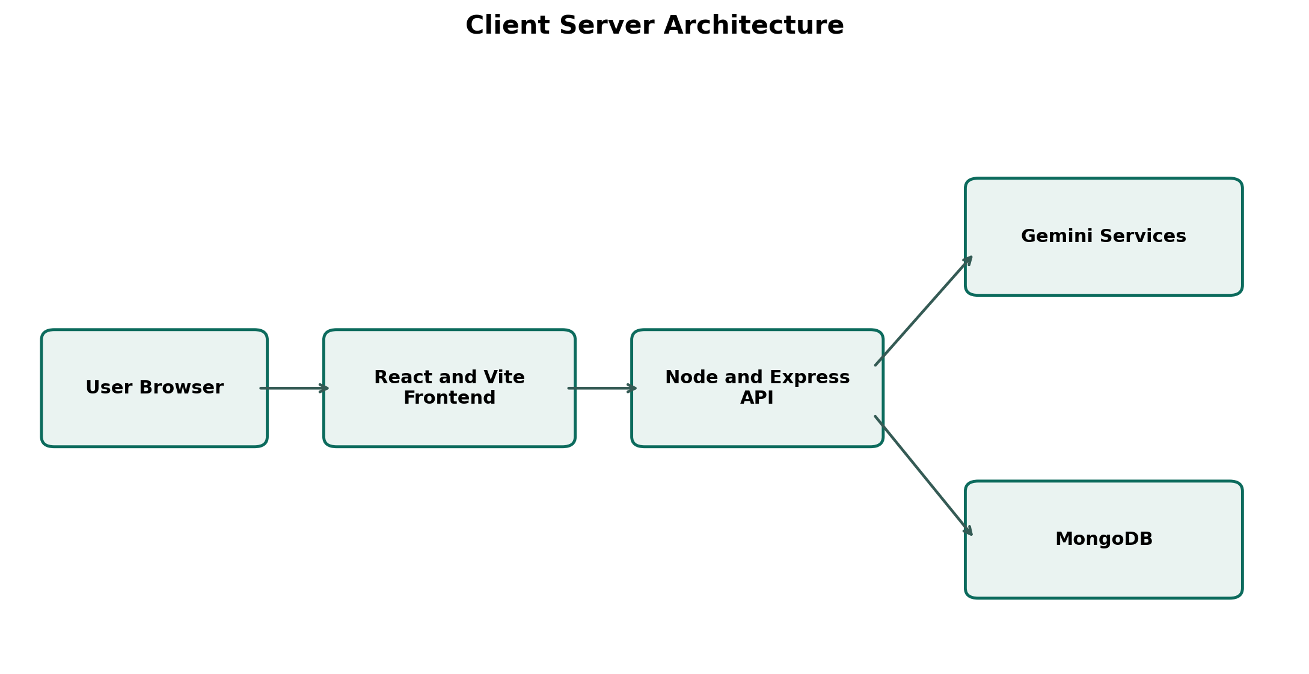
Figure 3.2 Client-server architecture of Fassara

3.4.2 Use Case Analysis
Table 3.5 Main use cases
Use case | Actor action | System response
Choose translation direction | Swaps Hausa and English | Updates source and target labels and clears a stale result.
Record speech | Grants microphone permission and records | Captures chunks, creates an audio file and provides a preview.
Upload audio | Chooses an audio file | Displays the selected file and prepares it for submission.
Process speech | Submits valid audio | Validates, transcribes, translates and returns structured output.
Play translation | Selects Play in translated output | Generates WAV audio and plays it; Play changes to Stop.
Save result | Selects Save | Creates a MongoDB or temporary history record.
Manage history | Views or deletes results | Returns recent items or removes selected records.

3.5 User Interface Design

3.5.1 Input Design
Inputs were limited to information required for the workflow. The language direction uses controlled values, ha and en, rather than free text. Audio is supplied as one multipart field named audio. Duration is recorded for metadata but does not determine transcription. Voice generation accepts translated text and a supported language code. History saving accepts the source language, target language, transcript, translation, audio name and duration. Server-side validation remains necessary because browser controls can be bypassed.
Table 3.6 Input validation rules
Input | Rule | Failure response
Audio | Required; MIME type begins with audio; maximum 15 MB | Request rejected with a clear audio message.
Source language | Must be ha or en | Unsupported-language message.
Target language | Must be ha or en and differ from source | Different-language selection required.
Voice text | Required after trimming; maximum 5,000 characters | No-text or excessive-length message.
Saved result | Transcript and translation are required | No result to save.
History identifier | Passed as route parameter for deletion | Matching record removed when present.

3.5.2 Output Design
The primary outputs are the original transcript and translated text, each displayed in a separate labelled result component. Copy controls allow reuse outside the application. The translated result additionally contains Play or Stop state and an intermediate Generating state. Success is shown when a result has been saved. The history output presents the language direction, date, original text and translation together. Error output is placed in the active workspace so that the user can correct the problem without navigating away.

3.6 Database Design
MongoDB stores one document for each saved translation. The design intentionally excludes raw audio. Mongoose restricts language values to ha and en, requires transcript and translation, trims text and adds timestamps. The audio name and duration provide lightweight context. Because the application has no login in its initial scope, records are not associated with individual accounts.
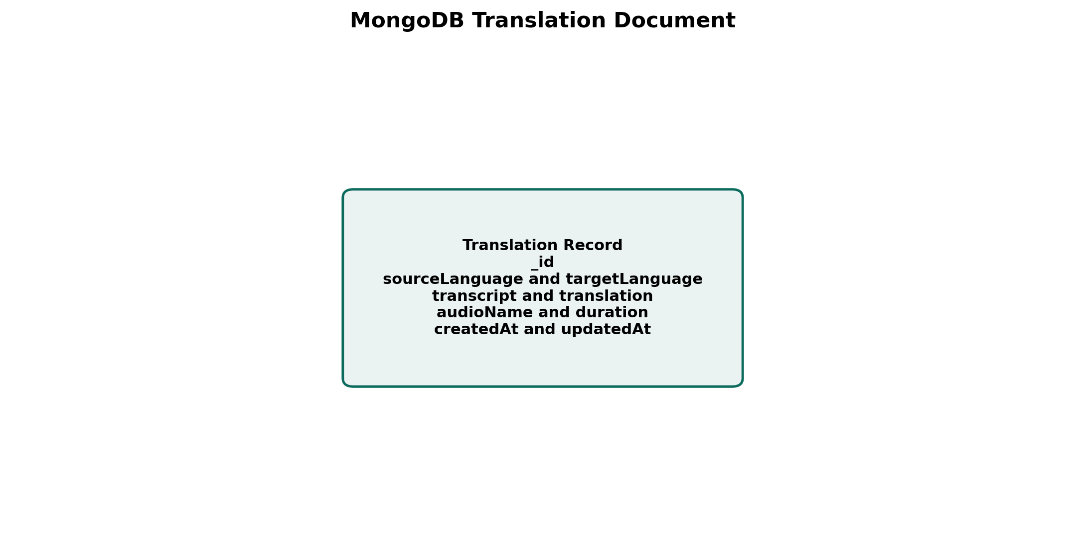
Figure 3.3 Translation document structure

3.7 API Design
Table 3.7 API endpoints
Method | Endpoint | Purpose
GET | /api/health | Return server status.
POST | /api/speech/process | Receive multipart audio and return transcript plus translation.
POST | /api/speech/generate | Receive text and language and return WAV audio.
POST | /api/history | Create a saved translation record.
GET | /api/history | Return saved records in recent-first order.
DELETE | /api/history/:id | Delete one record.
DELETE | /api/history | Delete all records.

3.8 Security and Privacy Design
Secrets are loaded from the backend environment using dotenv. The browser communicates only with the project API, so the Gemini key does not appear in frontend source or network request code. CORS limits the development origin to the configured client address. The production server can serve the built frontend from the same origin.
Multer stores the uploaded audio in memory and applies a 15 MB maximum. The service converts the temporary bytes to base64 for the external request; it does not write audio into MongoDB. Only text and metadata are saved when the user chooses Save. JSON bodies are limited to 1 MB. These controls reduce accidental resource use, although a public production deployment would also require rate limiting, authentication where personal histories are retained, HTTPS, logging controls and a privacy notice.

3.9 Testing Plan
Testing was planned at three levels. Build verification checks whether the frontend compiles. API functional testing exercises health, audio processing, validation and history endpoints. Manual interface testing covers recording, upload, result presentation, copying, saving, deletion, responsive layout and voice playback in a correctly configured environment. Broader language evaluation should use verified Hausa and English recordings to calculate WER and obtain bilingual ratings. The reported results in Chapter Four distinguish completed functional tests from recommended larger-sample language evaluation.

